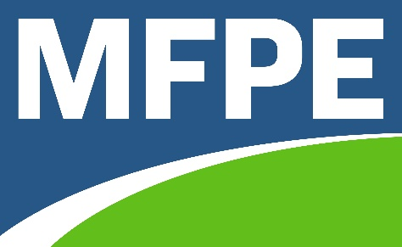

2020 Calendar

February - March Regional Meetings
February 25 Great Falls Regional Meeting 5:30 pm Great Falls EA Office
February 26 Helena Regional Meeting 5:30 pm Helena College
February 27 Butte Regional Meeting 6:00 pm Carpenters Union Hall
March 3 Havre Regional Meeting 6:00 pm Char’s Diner
March 4 Wolf Point Regional Meeting 6:00 pm Sherman Inn
March 5 Missoula Regional Meeting 5:15 pm Hellgate High School
March 7 Miles City Regional Meeting 1:00 pm Black Iron Grill
March 11 Kalispell Regional Meeting 5:30 pm NW MT History Museum
March 12 Bozeman Regional Meeting 5:30 pm Bozeman Public Library
March 19 Billings Regional Meeting 5 pm Virtual

April
03 MFPE Board of Directors/PAC
TBA Alternative MFPE Conference - Survey Monkey Voting
25 Eastern Montana Training (Cancelled)

May
16 MFPE PAC Helena
TBA State & Local Government Leadership Conference TBA (Cancelled)

June
9-11 Officers and Management Double Arrow
25-27 Montana AFL-CIO Convention Fairmont

July
2-6 NEA RA Atlanta
27-30 AFT Convention Houston

August
7-8 MFPE Board of Directors Helena

October
15-16 Educator Conference Great Falls

