NOMINATED FOR: PRESIDENT

My name is Dawnita “Beth” Juneau. I am an enrolled member of the Chippewa-Cree tribe of Rocky Boy. I was born and raised in Browning on the Blackfeet Reservation but have lived in Great Falls and have been a part of this community for 25 years. I am the mother of a third-year college student and have 4 yearsof college myself. At the present time I work for the Office of Public Assistance here in Great Falls. In the past I worked for the Great Falls School District, in Indian Education and for the State’s Vocational Rehabilitation program.

Currently and in the past, I have held positions that have allowed me to advocate, lift up and support those in need. I am very civic minded and am a proponent of what is right and just. After attending my first MFPE Regional Conference a couple of years ago, I knew I wanted to learn and to be a part of a working union. Thereby I chose to run for office in our Local Union and was elected as it’s Secretary/Treasurer. This position allowed me to learn more about how our Union is working for our members in real-time. I continue to look for opportunities tohelp my fellow workers, be a supporter of all the hard work you do, and this is why I am running for President.

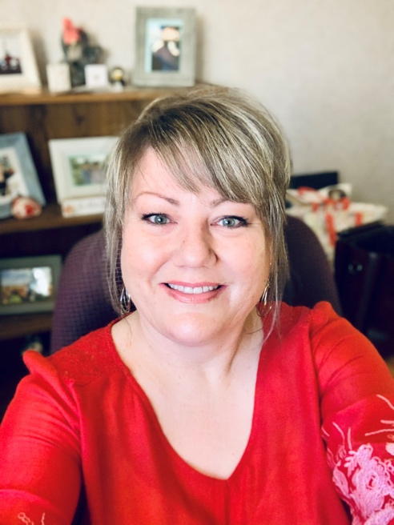
________________________________________________________________
NOMINATED FOR: PRESIDENT, VICE PRESIDENT, SECRETARY TREASURER, AND MEMBER AT LARGE

Sunny D. (Berg) Kloepfer is a native to Montana, enrolled in the Crow Tribe and has been working in the office setting in Billings, Montana for 25 years. Her field of experience began as an assistant teacher in Pryor, pharmacy technician, medical records admin, office manager for a 250 unit Mobil Home Park. She had obtained two degrees while raising 4 children. First degree obtained was an Associates in Business Management and the other degree was bachelor’s in History/Political Science w/option of teaching from MSUBILLINGS. The last 16 years, she has spent working for families as a Resource Specialist for American Indian Children in therapeutic foster care , case managing at local community action agencies, and currently working for the State of Montana in the Office of Public Assistance for the last 8 years. When Sunny is not working, she loves traveling to Montana’s best kept outdoor secret sanctuaries, writing songs with her flute, guitar and piano as well as spending time with her family and four beautiful grandchildren.
___________________________________________________________________
NOMINATED FOR: VICE PRESIDENT

Misty is an Eligibility Interview 3 at the Kalispell Office of Public Assistance. She graduated from Southern Oregon University with a degree in Music Education. She moved to Montana three years ago with her sister, and has truly enjoyed the beauty that Montana has to offer. She has always been invested in helping others in need, and has worked in education and customer service for a total of 11 years. Misty has worked for the Office of Public Assistance for approximately 2 years and some change, beginning her career as a Client Service Technician. She enjoys learning other languages and is trilingual, as well as playing music, photography, and coordinating game nights with her loved ones.

__________________________________________________________________________________________
NOMINATED FOR: SECRETARY TREASURER

My name is Tori, and I work as an eligibility technician for the Office of Public Assistance. I have been an employee with the State of Montana for the last two and a half years. Most of my adult life has been spent within employment opportunities that allow me to serve the community. I spent time as direct care staff within Butte group homes, and then later assisted individuals with various disabilities find and maintain employment. I am also a mother to a very sweet, loving young man, as well as two cats and a dog. I find the most satisfaction is gained by assisting others. I am a fourth-generation union member; My great grandfathers, grandfathers, and father have all been active union members throughout their careers. I am proud to serve my community and am proud of the nomination to serve my coworkers through our local.
__________________________________________________________________________________________
NOMINATED FOR: SECRETARY TREASURER
Hello,
My name is Katie Bisch, I have been with OPA since September of 2020. I am a lifelong resident of Anaconda. My husband and I have two teenage sons and enjoy chasing them around the state in their extracurricular activities.

I have been a part of Unions since I began working with the Anaconda School District in 2012. While I never held an officer position, I was part of annual negotiation meetings representing my fellow School Secretaries and Paraprofessionals. I come from a long line of Union strong family, as members of the local teachers union. Anaconda is a very Union strong community, it’s in my blood.

Being nominated for the secretary/treasurer is an honor. I have an AA in Accounting, I’ve worked as a loan
officer and a vault teller, and prior to joining the OPA I was in HR for the local school district, among other duties. I would thoroughly enjoy being the secretary/treasurer, if chosen.

Thank you for the nomination!
_______________________________________________________________________________________
NOMINATED FOR: SECRETARY TREASURER

(Crystal Haines)
I was born and raised in Portland Oregon. I moved to Montana in 2005. I have 14+ years of customer service experience, 6+ years of accounting experience and 3 years of college education at MSU Billings towards my Bachelor’s degree in Psychology. I am passionate about mental, emotional and physical wellbeing achieved through holistic approaches. I have been at the Kalispell OPA since 12/26/2018, currently in the Medically Needy Unit and find my job tasks and responsibilities to be very rewarding. I am excited to take on new challenges that create opportunity for personal growth, and positively contribute to my local community.
_______________________________________________________________________________________
Mimi Mellor
Submission not yet received
__________________________________________________________________________________________
NOMINATED FOR: MEMBER AT LARGE REGION 1
My name is Lance Deitrick and I am based in the Kalispell OPA. I am married with 4 children, 2 boys and 2 girls, ranging in age from 8 to 19 along with 2 yorkies (Mickey and Minnie) and recently a rescue bunny who has become affectionately known our “grand bunny”. My wife and I are both state employees and are invested in having long term, fulfilling careers serving the people of Montana.

I have been with the OPA just under 3 years and currently work in the Medically Needy Unit doing maintenance on ABD programs. I have over 30 years of experience in multiple industries including Semiconductor, Call Center Support and Management, Client Services Account Management along with a stint of being self employed and owning a general contracting business. During this time I have been both laborer as well as a manager where I have gained perspective from both viewpoints.

I am passionate about having a healthy balance of home life and work life and believe we should have fun at work everyday, it’s all a matter of perspective! Additionally, I am an advocate of climate change awareness and doing what I can to reduce my carbon footprint where I can. My goal is to bike commute at least 140 days a year to work (last year I managed 120!).

I do believe that I can bring a unique skill set into this role as I have spent time both in labor and management roles and understand that what is the most important is to “listen to understand, not to respond”.

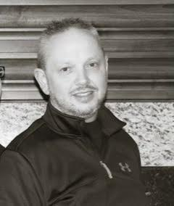

_________________________________________________________________
NOMINATED FOR: MEMBER AT LARGE REGION 1

Nikki is a Client Service Coordinator (Eligibility Interviewer 3) at the Flathead County OPA. She is a graduate of Flathead Valley Community College, having obtained her AAS in Emergency Management. She's always worked for the betterment of society with four years as a 911 Dispatcher, a year and a half as an Emergency Management Planner, and two and half years with the State as a CSC. Overall, she has roughly 20 years of customer service job history. She is married and the mother of two children, three dogs, a tarantula, and A LOT of fish. She loves hiking and kayaking with her family and tending to her garden during the summer months.
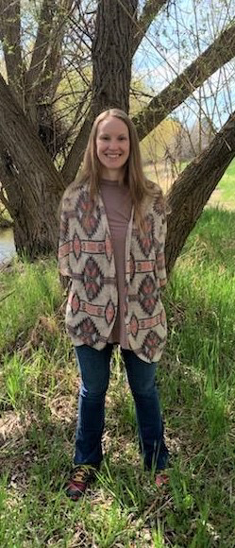

___________________________________________________________________
NOMINATED FOR: MEMBER AT LARGE REGION 1

Melissa works for the Public Assistance Bureau as a Career Development Specialist. She previously worked as a Client Service Coordinator for 5 ½ years. She has a passion for training, education, and public service. She’s worked in elementary education, health insurance, and life insurance fields. She lives in Missoula with her husband, daughter, and two dogs/office assistants. On any given day you might find her hiking in the gorgeous Montana outdoors or dancing to loud music. 😊
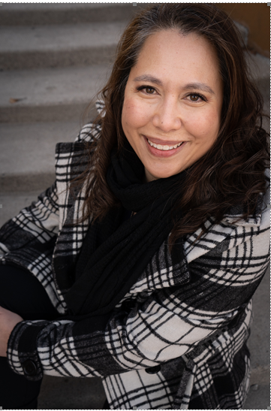

___________________________________________________________________
NOMINATED FOR: MEMBER AT LARGE REGION 2

Amber Boyer
Billings MT
2 years

I was brought up to respect the union and the power of labor by my grandfather. I've always held a passion for assisting employees and organizations work together for the betterment of the populations we serve.
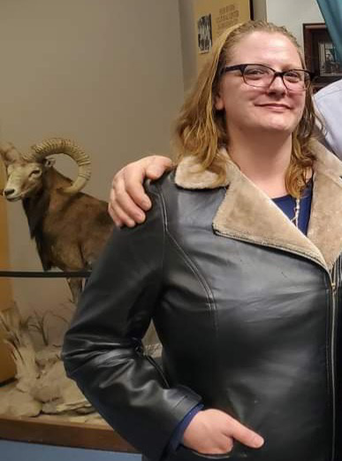

___________________________________________________________________
NOMINATED FOR: MEMBER AT LARGE REGION 2

Mike Guy Bio
For union election

​My name is Mike Guy. I have been with the OPA for seven years, starting with the Eastern Processing Center then moving to the Billings OPA when the two merged. I am a retired Billings Police Officer after 25 years and a retired Ambulance EMT. I am married and we have six kids, five of them married and the 6th doesn’t know he is. We also have 7 Grandkids, 4 boys- 3 girls, and 1 dog. We love to travel and camp as well as other hobbies. I have been in a Union most of my adult life, but I know nothing about serving for one. But, I am a good student, and I will do my best. Thanks for your time.

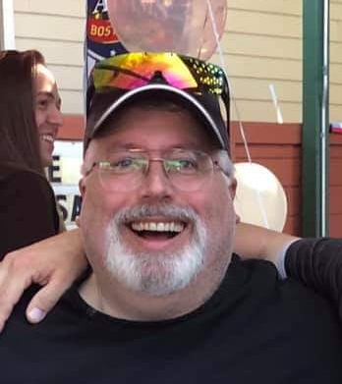

___________________________________________________________________
NOMINATED FOR: MEMBER AT LARGE REGION 3
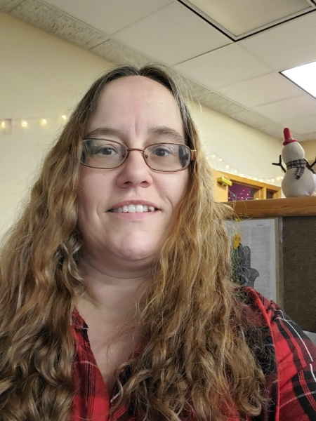
My name is Roberta Smerker, I have been working at OPA for 5 ½ years, I have enjoyed several of the annual conferences with the union. The
Powerful team building we do at those annual conferences is amazing! Also meeting new people from around the State has been wonderful as well. I enjoy learning all the aspects of the union and what all goes on behind the scenes.
Look forward to working with other MFPE members

