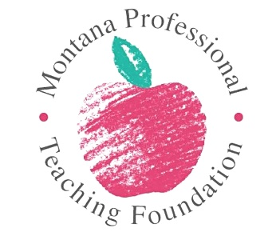
2025 ESP of the Year Nominations
Educational Support Professional (ESP) of the Year is an award given to a classified school or university employee who:
- Positively impacts student learning, social-emotional well-being, health, and/or safety
- Positively impacts families and/or the local community
- Uses union engagement and activism to positively impact other school or university employees' professional importance and reputation, wages, working conditions, and/or effectiveness
- Positively impacts colleagues
ESPs are the paraprofessionals, education support professionals, bus drivers, cafeteria workers, maintenance and janitorial staff, and so many others from pre-K to higher education who help students find success. Everyone knows an ESP deserving of this award. Now’s the time to nominate them!
Simply fill out this nomination form and return it by email to Donna Graveley at dgraveley@mfpe.org.
Your name:
Your email address:
Your phone number:

Nominee’s name:
Nominee’s email address:
Nominee’s phone number:
Nominee’s school district:
Nominee’s position:

One paragraph statement explaining the nominee’s impact on their school or campus:

